AU2008.1 Spreadsheet Instructions

Sheet Start-up From Scratch

- Open your turn .txt file. Note the .pdf file will not work.
  - Select All by pressing Ctrl-A.
  - Copy All by pressing Ctrl-C.
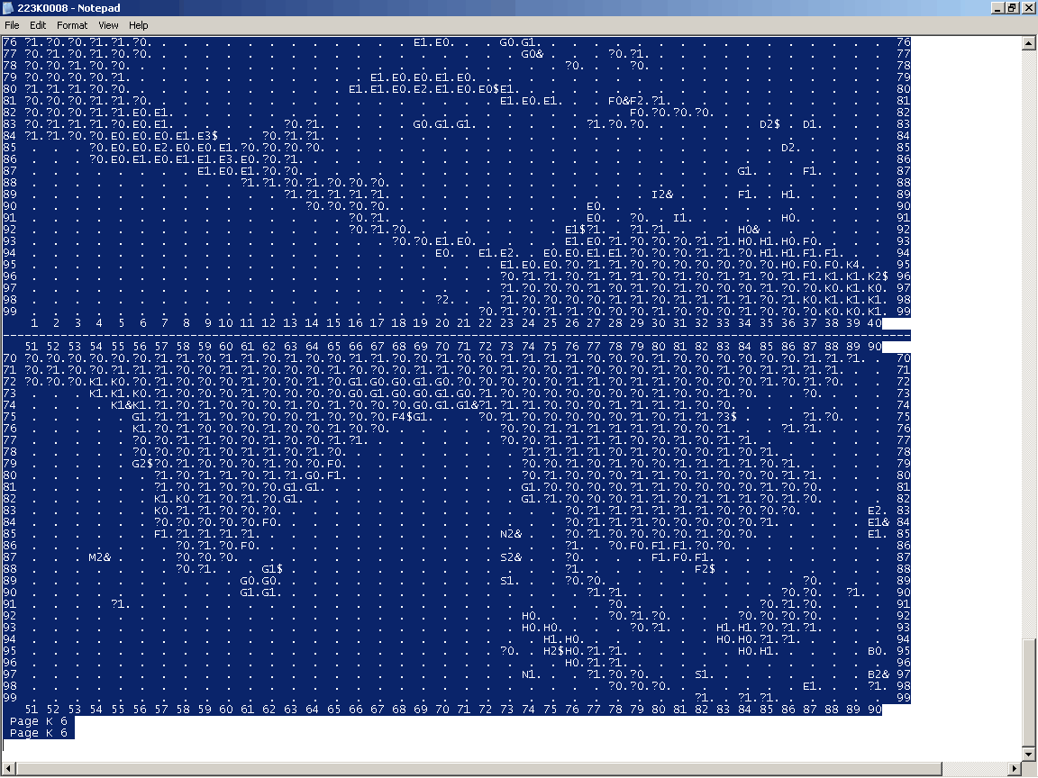

- Open your AU spreadsheet and select “Enable Macro’s” when asked.
- Go to “Front” sheet and select your Nation and the Month in the top left hand corner.
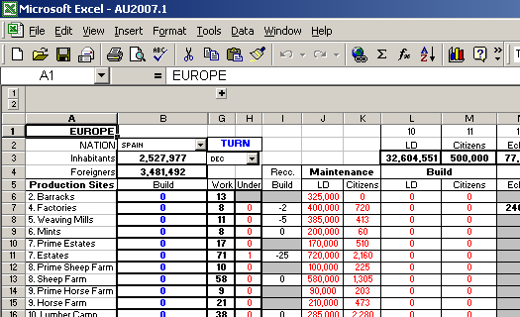

- Go to “Paste Here” sheet and select column “A” at the top.
  - Hit “Delete” to clear all the cells in column A.
  - Select Cell “A1” so that only one cell is highlighted.
  - Paste your turn by pressing Ctrl-V.
- Hit the “Austerlitz” button to generate your turn.

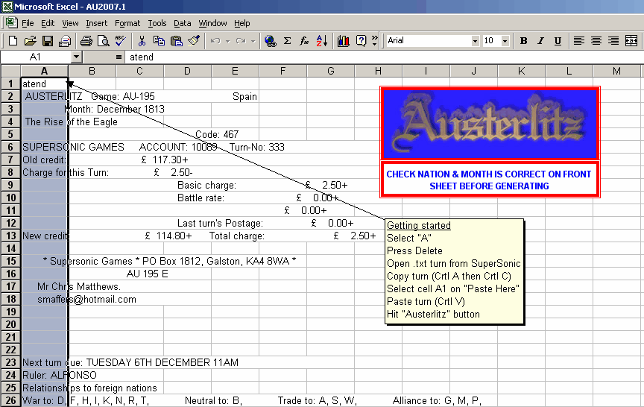

- Go to “Army” sheet.
  - Update Commander ratings and add Commanders as required.
  - Delete any troop builds, repairs, training.
  - Press the “Calculate Troop Build Costs” button. This should zero all build costs.
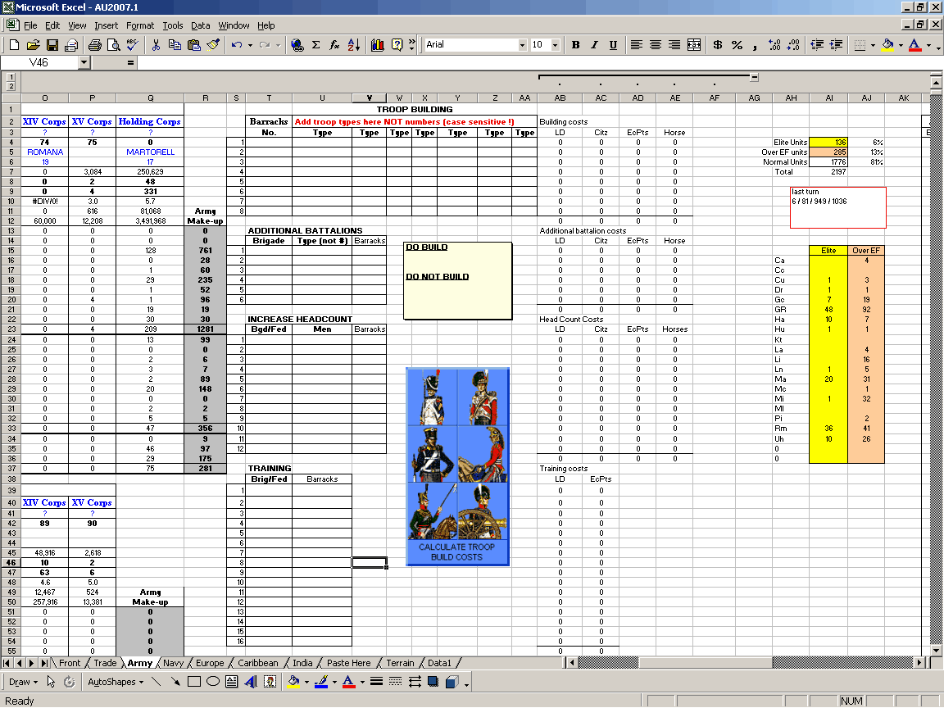

- Go to “Navy” sheet.
  - Delete all ship/baggage builds and repairs.
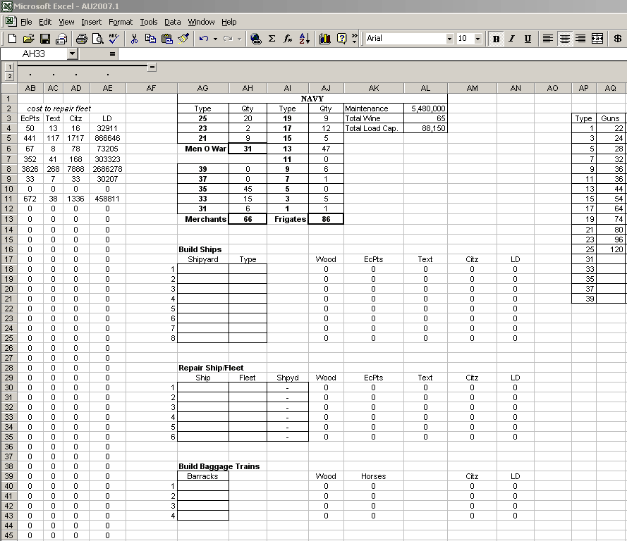

- Go to “Trade” sheet.
  - Delete all sales and purchases.
  - Press “Calculate Trade” button to zero cells
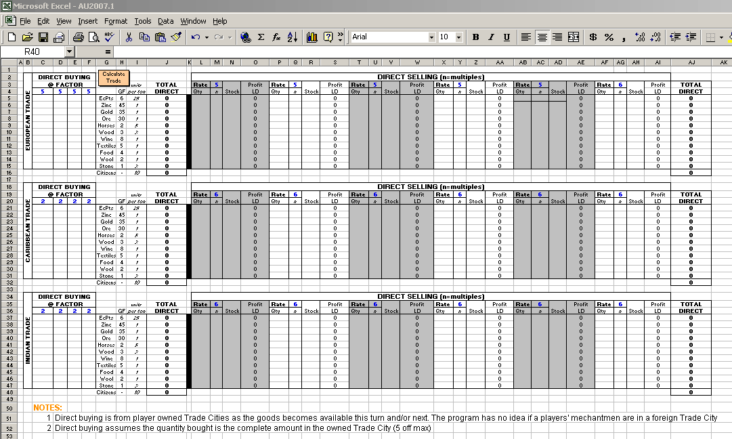

- Go to “Front” sheet.
  - Zero all Production site builds in Europe and Colonies (column B)
  - Zero all Population increases in Europe and Colonies (column L)
  - Zero all Inter-Warehouse Louisdore transfers.
  - Manually set all European barrack political spheres, ie H, PS or F. To be done every turn.
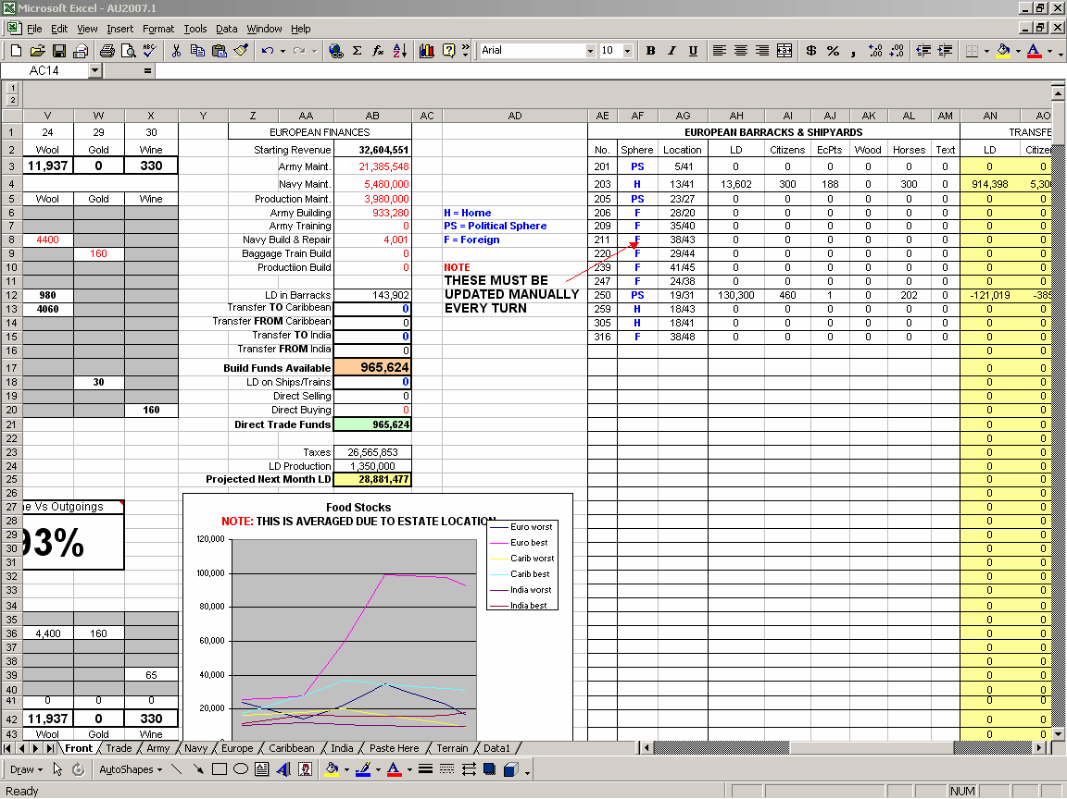
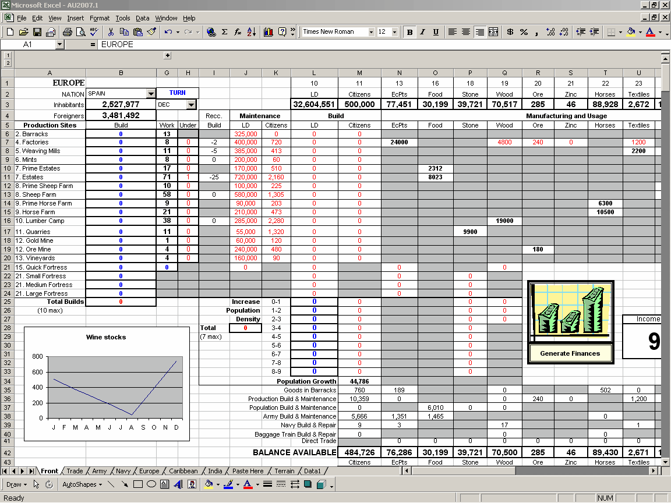
Sheet Explanations

Front Sheet
- The sheet is split into 3 sections to represent the 3 warehouses, Europe, Caribbean and India.
- Each warehouse’s LD and stock is shown horizontally across the top of each section.
- The number of Production sites per warehouse are shown in column G (in black). These are automatically generated when the “Austerlitz” button was pressed.
- To build a production site simply add the quantity required in column B (in blue). A maximum of 10 sites can be built and the sum of all builds is shown in cell H25.
- Recommended production sites are shown in column I.
- Maintenance and approximate citizen costs are shown for your information.
- Fortresses can be built in cells G22:24.
- All goods for builds are extracted from the relevant warehouses.
- Goods generated by production sites are shown in Black and goods used by production sites are shown in Red.
- Population increases are carried out by putting the quantity required in cells L25:33, L69:77 and L116:124. A maximum of 7 population increases are permitted and the sum of all increases are shown in cell J28.
- Production site maintenance is split between the relevant warehouse as per the rulebook.
- Army and Navy maintenance and all LD build costs are shown in column AB.
- The LD costs for direct Trading are also removed from LD available in column AB.
- Two cells per warehouse are available in column AB for transferring LD between warehouses.
- LD Income from Taxes, Mints and Direct selling is shown in cells AB19:AB24 for Europe, cells AB63:67 for Caribbean and AB110:114 for India, together with a prospective LD total for next month.
- A graph is provided to show a 12-month Food forecast. This is only updated when the “Generate Finances” button is pressed. NOTE : this is an estimated production based on “home” nation averages, ie counts ALL prime and normal estates but uses the climate factors on page 23 of the rules.
- The barracks are shown in columns AE:AM. The LD and goods are generated automatically when the turn is generated.
- The LD and goods that need to be transferred into the relevant barracks are shown in columns AN:AS. NOTE: Changes in the Army and Navy sheets will NOT be reflected in the transfers until the “Generate Finances” button is pressed.
- A box is shown next to the Generate Finances button to show the ratio of Total Income vs Outgoings. The closer to 100% the closer the economy is to using it’s cash reserves. Over 100% and it is using it reserves, ie in the red.
- Goods Balance Available is shown in Red if there is a negative balance and you need more raw materials. The recommended builds will also reflect the deficit.
- Nation and turn month are shown in the top left hand corner.
Trade Sheet

- Trade only covers Direct Selling or Buying within a players own Trade Cities. This is because the funds can be utilised for more trading or for next turn. When purchasing the program assumes that the trade city is being emptied of that particular item. (this is the most cost effective method of trade)
- The trade is split into European, Caribbean and Indian trade.
- 4 Trade Cities are allotted for Direct Buying in columns C:F.
- Change the Trade City rates to the respective values (blue text).
- Enter the amount of goods you wish to purchase.
- The program calculates the cost and removes the LD from the respective warehouse.
- Money made from selling is shown in the next month’s projected income.
- 6 Trade Cities are alloted for Direct Selling in columns L:AI.
- Change the Trade City rates to the respective values (blue text).
- Enter the quantities you wish to sell under “Qty” and next to the goods you wish to buy.
- Enter the multiples you wish to sell under “n”. 36 is the maximum per turn.
- Enter the stock which is held within the Trade City (before trade) under “Stock”.
- Press the “Calculate Trade” button to generate the profit of Direct Selling. The LD will be added to the Direct Selling cell in the front sheet.

Army Sheet

- The entire army is listed in federation order in columns AL:BJ.
- Brigade weights are shown in column BL.
- Army Federations are shown in columns A:R.
- You can name you federations next to Corps Name.
- Commanders and their ratings are manually placed under their respective federations.
- A complete breakdown of each Fedration is given including numbers of brigades, battalions, weight, men, average EF, maintenance and troop breakdown.
- An overview of the entire army is shown in the grey cells in columns Q and R.
- Elite troops are those that have maximum allowable EF. They are highlighted yellow in the army lists.
- Over EF troops are 1 EF over their normal EF and are highlighted in orange.
- Troops that require training are highlighted green.
- Troops are built by putting the barracks and then the troop type, not number, in the cells provided under Troop Building. NOTE: This is CASE SENSITIVE and must be as per the rulebook, ie grenadiers for France are “Gr” but all other countries are “GR”. The program determines the difference between Be for GB and Turkey.
- Only brigades in barracks can have additional battalions added to them. Again, this is case sensitive. If the brigade is being trained as well the training costs for the Additional Battalion will be added. The barracks number will be entered automatically.
- Brigades or entire Feds can have their headcount increased. The barracks is entered automatically. NOTE that the program doesn’t calculate if the EF is reduced from excessive headcount increase. If this is going to be the case then manually adjust the EF and HC of the battalions in the army list before hitting the calculation button.
- Brigades or entire Feds can be trained by adding the numbers in the allocated cells. The barracks number is generated automatically.
- Once all builds, increases and training has been entered press the “Calculate Troop Build Costs” button to generate the costs. NOTE: This doesn’t automatically update the Front Sheet. See Front Sheet instructions.
- Always press the “Calculate Troop Build Costs” button if changes are made to the sheet.

Navy Sheet

- The entire Navy is shown in numerical order on the left hand side of the sheet.
- The maintenance and repair costs are shown against each ship.
- The Fleet listing is shown in columns U:AE. This shows the Fleet number, location, loading capacity and gives a breakdown of the type of ships in the Fleet. Types 21, 23 and 25 are considered to be Men-of-War (MOW), all other warships are Frigates.
- A breakdown of the entire Navy is given in cells AG:AK, together with Maintenance, Wine required and total loading capacity.
- To build a Ship you simply put the type and barracks number in the cells provided. The Front Sheet is NOT automatically updated for builds until the “Generate Finances” button is pressed.
- To repair a Ship you simply put the ship number in cells AG. The barracks and Front Sheet is NOT automatically updated for repairs until the “Generate Finances” button is pressed.
- To repair a Fleet you simply put the Fleet number in cells AH. The barracks and Front Sheet is NOT automatically updated for repairs until the “Generate Finances” button is pressed.
- To build a Baggage Train you simply put the barracks number in the cells provided. The Front Sheet is NOT automatically updated for builds until the “Generate Finances” button is pressed.

Map Sheets

- The map sheets have icons supplied to help map unit movements. Double clicking the text on the icon will allow the text to be modified.
- The European map shows an approximate population comparison in cells CK:CN. This is generated from the co-ordinates owned by a nation and the average population figures in the rulebook.
- Each map lists the production sites that have the minimum population for each nation. The European map totals all the production sites for all the maps for comparison.
- HINT: If a fleet is spotted it appears on the map. Right clicking the cell where it appears allows “Insert Comment” to be selected. If you add or modify a comment each time a fleet appears on can plot shipping lanes that a potential enemy might use. Comments can also be added to remind you to avoid the
co-ordinate if dead nation’s fleets are there.

Terrain and Data1 Sheets

Please do not change any information held in the sheets.
The Terrain maps can be printed to help plan your move.

